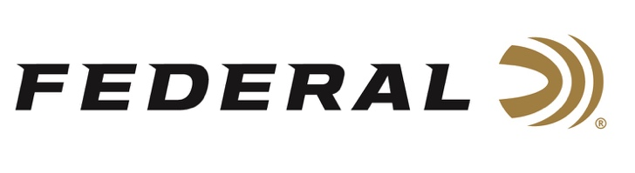

FOR IMMEDIATE RELEASE

Federal Congratulates Olympic Medalists

ANOKA, Minnesota – August 11, 2021 – Federal Ammunition congratulates the USA Shooting shotgun team members who won Olympic medals in Tokyo. Federal sponsored shooters Vincent Hancock, Kayle Browning and Brian Burrows captured medals in their events against the world’s best on the biggest stage. Federal sponsored shooters Austen Smith and Derrick Mein also competed and turned in excellent performances but fell short of reaching their goals of an Olympic medal.

“Our company couldn’t be prouder of the performances of our sponsored team of world class shooters at the Olympic games,” stated Jason Vanderbrink, President of Federal Ammunition. “They competed at the highest level against the world’s best shotgun shooters and were simply amazing. It brings such pride to our dedicated American employees that these athletes achieved their dreams of standing on the podium with an Olympic medal having used our American made products,” stated Vanderbrink.

Vincent Hancock is now a 3-Time Olympic Champion following his gold medal performance in Tokyo. Hancock made the Men’s Skeet finals in a shoot-off and then bested the remaining five contenders hitting 59 of 60 targets, setting an Olympic record. Hancock is the first shooter to ever win three gold medals in this event, adding to the ones he won in Beijing in 2008 and London in 2012.

Kayle Browning captured a silver medal in Women’s Trap. Browning, an Arkansas native, shot her way into the finals in the sixth position and then climbed into the final pairing with some clutch shooting. The first time Olympian missed extending the match by one target but was elated winning silver for the United States of America.

In its Olympic debut, Federal-sponsored athlete Brian Burrows and teammate Madelynn Bernau claimed the bronze medal at the Tokyo Olympic Games. The pair qualified for the bronze match by posting a 146/150 in the qualifications. In their bronze medal match, they faced the mixed team from Slovakia which included the women’s individual gold medalist in trap. The pair of Burrows and Bernau won in a dramatic shoot-off to finish third and represent the USA on the podium.

Austen Smith and Derrick Mein also competed in their disciplines of Women’s Skeet and Men’s Trap. Both competed at a high level in their first Olympic competition and gained valuable experience. All Federal sponsored shooters used Gold Medal Paper Shotshells built by American workers at an American manufacturing facility in Anoka, MN.

Federal is the official shotshell ammunition sponsor and supplier of USA Shooting, a non-profit organization that promotes the shooting sports and prepares American athletes to bring home Olympic gold. Learn more at: www.usashooting.org.

Federal Ammunition can be found at dealers nationwide or purchased online direct from Federal. For more information on all products from Federal or to shop online, visit www.federalpremium.com.

Photo Credit: Courtesy of USA Shooting

Press Release Contact: JJ Reich
Senior Manager – Press Relations
E-mail: VistaPressroom@VistaOutdoor.com

About Federal Ammunition
Federal, headquartered in Anoka, MN, is a brand of Vista Outdoor Inc., an outdoor sports and recreation company. From humble beginnings nestled among the lakes and woods of Minnesota, Federal Ammunition has evolved into one of the world's largest producers of sporting ammunition. Beginning in 1922, founding president, Charles L. Horn, paved the way for our success. Today, Federal carries on Horn's vision for quality products and service with the next generation of outdoorsmen and women. We maintain our position as experts in the science of ammunition production. Every day we manufacture products to enhance our customers' shooting experience while partnering with the conservation organizations that protect and support our outdoor heritage. We offer thousands of options in our Federal Premium and Federal® lines-it's what makes us the most complete ammunition company in the business and provides our customers with a choice no matter their pursuit.

